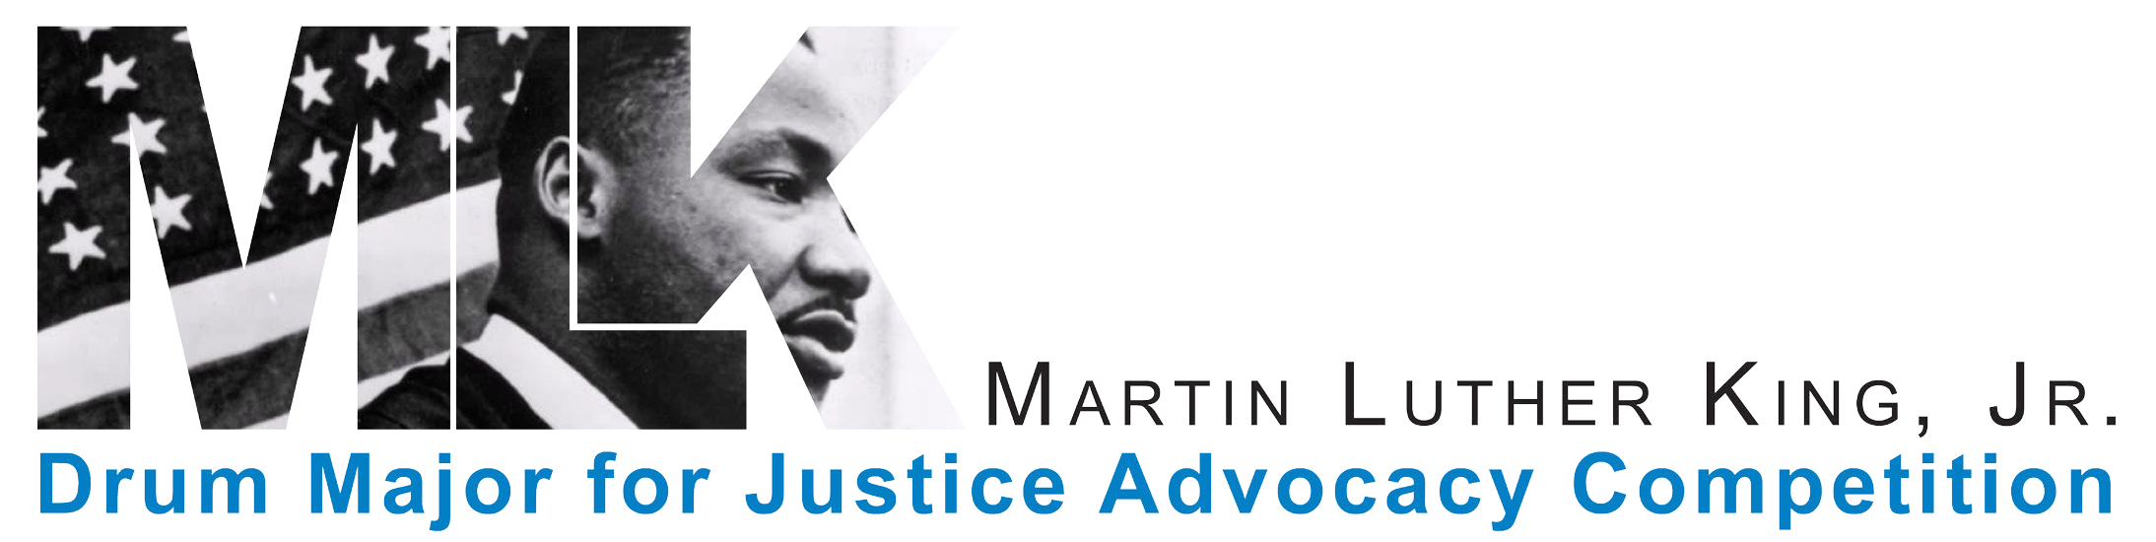

2021 Dr. Martin Luther King, Jr.
Drum Major For Justice Advocacy Competition
RULES & Handbook
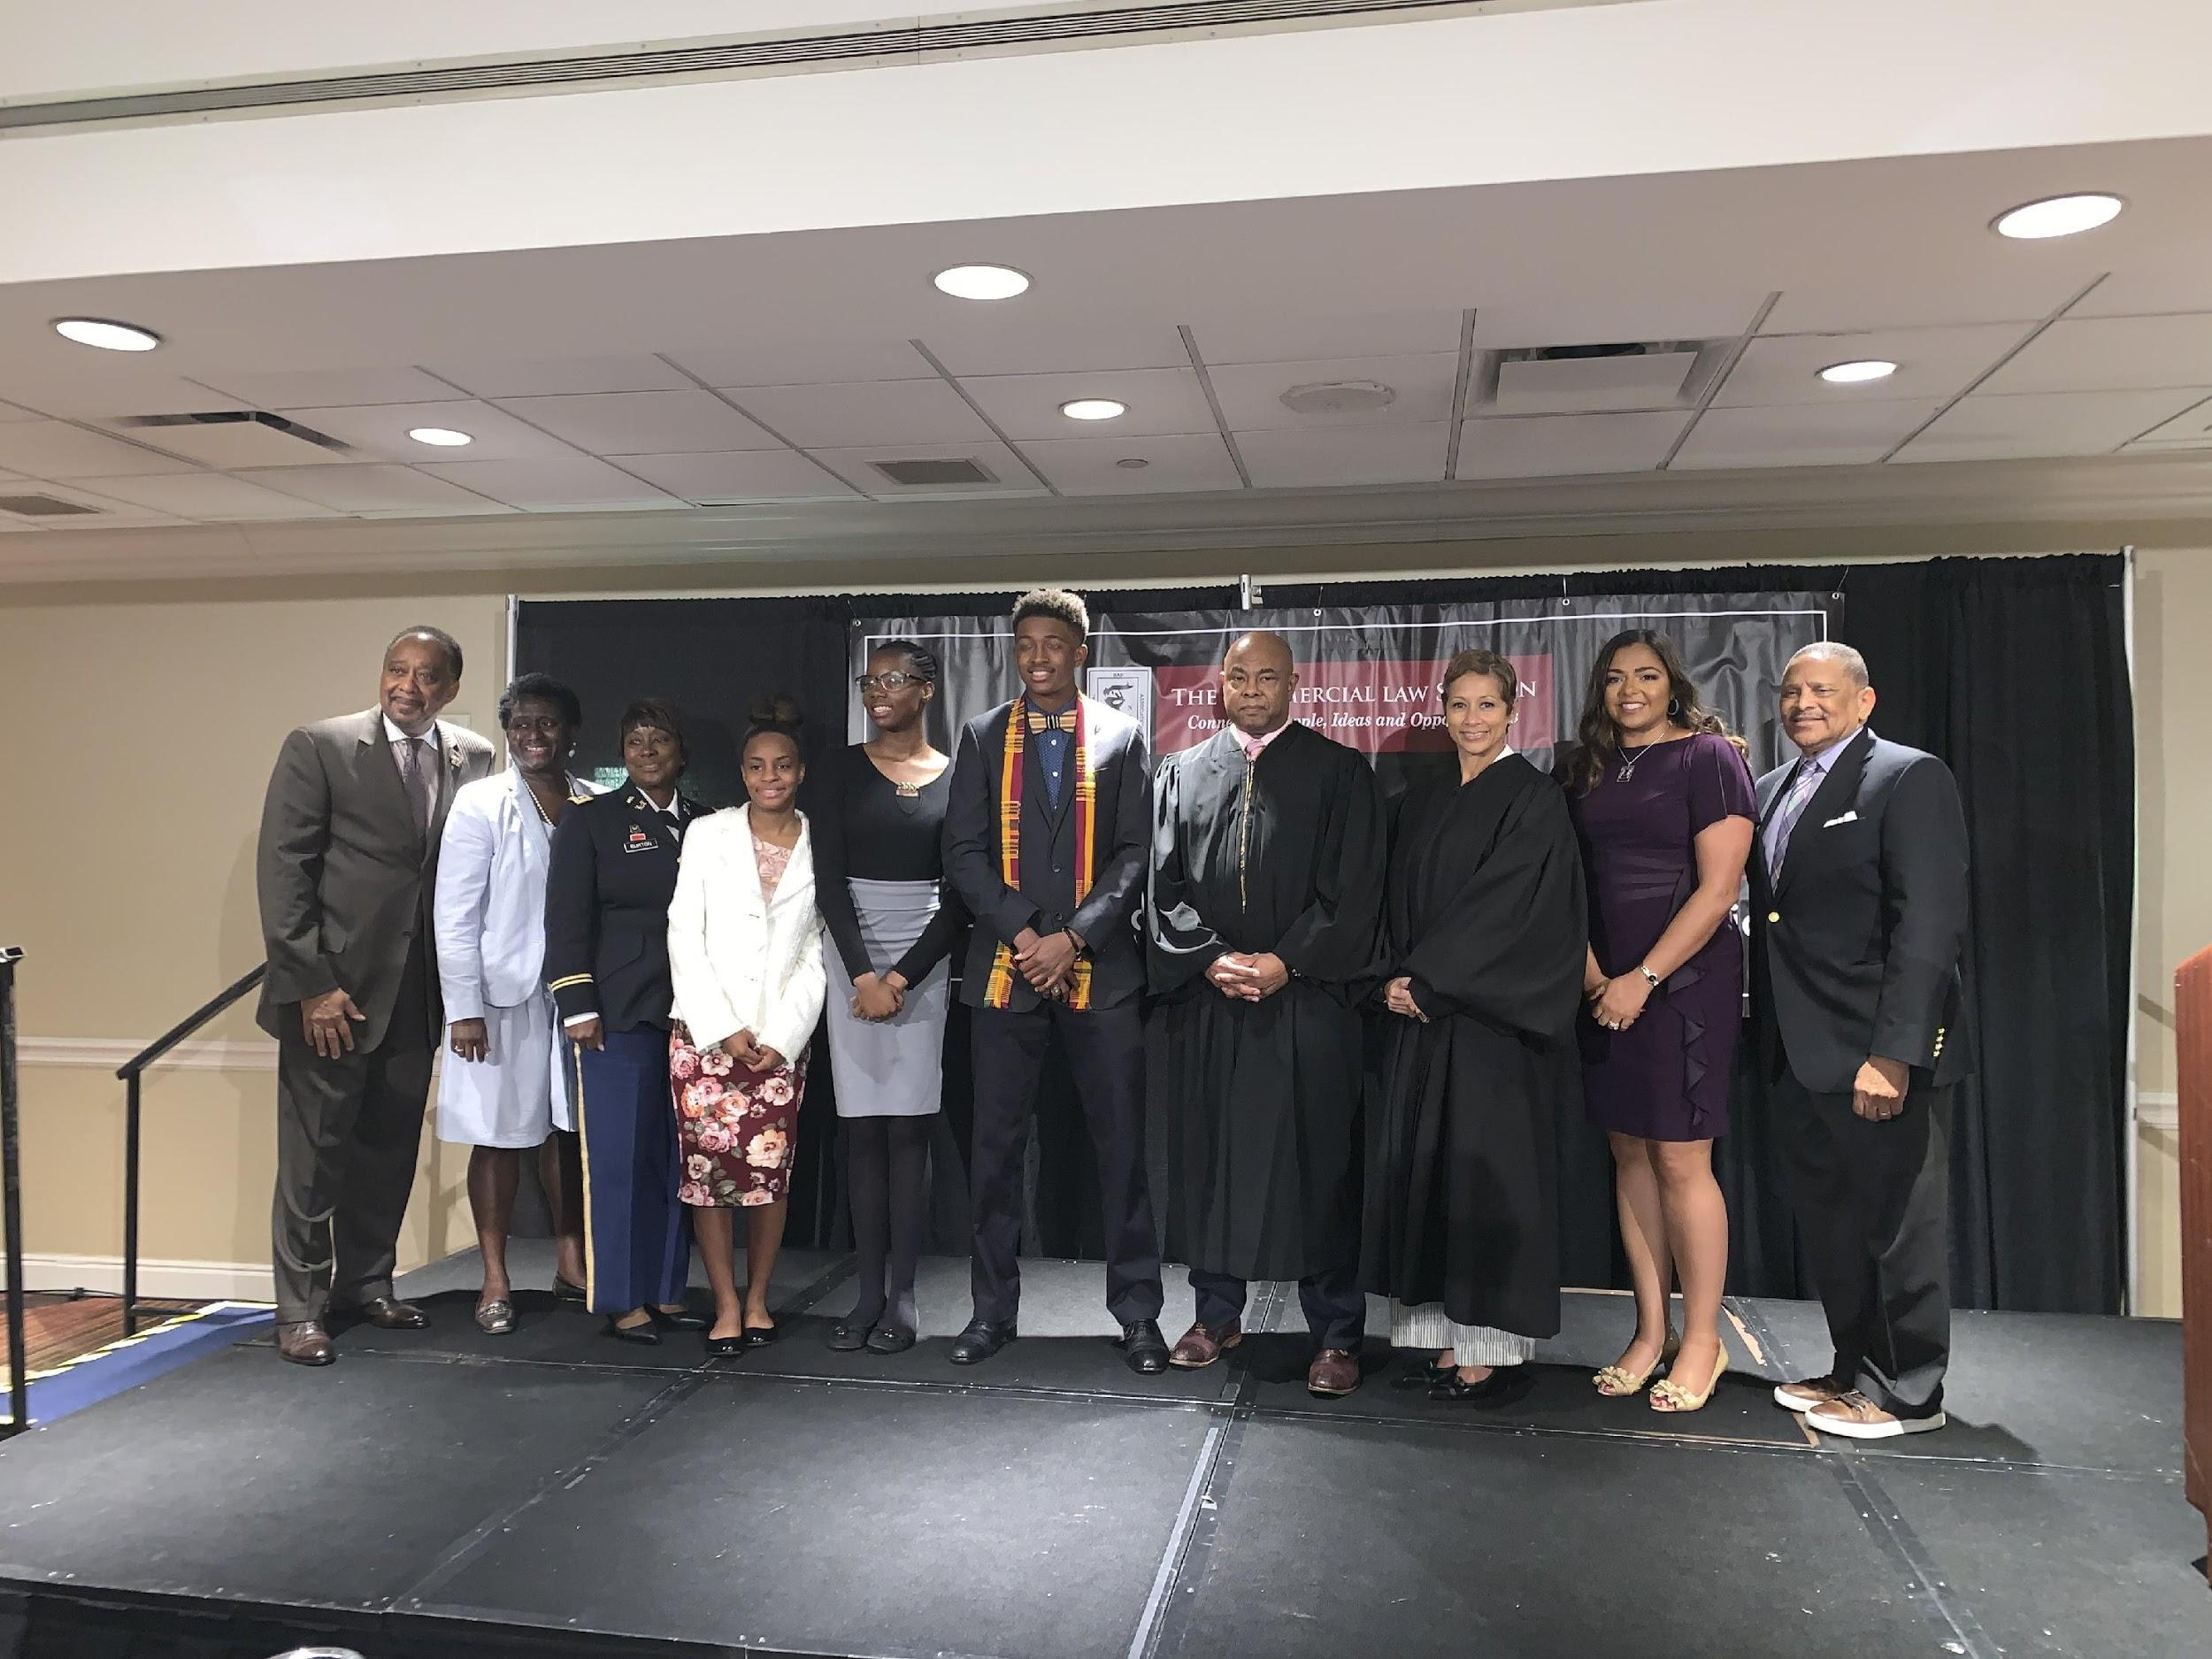

Memphis, TN
July 2021

PURPOSE AND HISTORY OF COMPETITION
The Dr. Martin Luther King, Jr. Drum Major for Justice Advocacy Competition is a contest designed to motivate high school students to excel in education. The Competition encourages students to express their views on a pre-selected topic and focuses on the ability of the students to communicate orally and in writing. The contest is also designed to give young people experience in public speaking and reviewing legal documents as well as provide an opportunity for them to obtain some financial support to continue their education.
The National Bar Association's ("NBA") inaugural Martin Luther King, Jr. Drum Major for Justice Advocacy Competition was held at the 75th Annual Convention in Washington, D.C., in 2000. The Competition originated under the leadership of NBA Past President Harold D. Pope with the assistance of Attorney Vanessa Miree Hayes and resulted from the historical success of a similar competition conducted by the NBA Affiliate Chapter, Wolverine Bar Association, Detroit, Michigan. As a result of the overwhelming success of the Competition, the NBA, with the support of the National Bar Institute ("NBI"), adopted it as a national program.
The successful foundation of the Competition was based primarily on the financial contribution of Ford Motor Company to the NBI with the guidance of Ford's In-House Counsel and NBI Past Board Member Alison Nelson. With the continued financial support of FedEx, General Motors, Metropolitan Life Insurance Company, State Farm Insurance Companies, Walmart Stores, Inc., and the National Bar Association Commercial Law Section, the Martin Luther King, Jr. Drum Major for Justice Advocacy Competition has been successfully held for twenty-one years and has evolved into a main program of the NBA and NBI.
The NBA and NBI will be celebrating the 20th Anniversary of the inaugural Martin Luther King, Jr. Drum Major for Justice Advocacy Competition at the 95th Annual Convention in Memphis, TN in July, 2021.
The topics of the Competition are always considered from the point of view of Dr. Martin Luther King, Jr., and have included:
- Law enforcement treatment of persons of Arab descent and of the Muslim faith in terrorist investigations.
- The need for reauthorization of the Voting Rights Act of 1965.
- Recommendations for action on the 40th Anniversary of the Voting Rights Act to address the continuing problem of voter disenfranchisement in minority communities.
- The treatment of juveniles in the criminal justice system.
- The right of same-sex couples to marry.
- Repealing of Stand Your Ground laws.
- The funneling of young African American students into a “pre-school to prison” pipeline.
- Support of the Black Lives Matter movement versus All Lives Matter debate.
- Support “The Green New Deal”
The National Bar Association through the National Bar Institute has awarded approximately $290,000.00 in scholarships to over one hundred and twelve (112) students since the inception of the Competition in 2000.

II. COMPETITION RULES
A. Essay Format:

1. The essay should be no longer than 1000 words.
2. The type font must be Arial, 12 point, double-spaced.
3. The margins must be 1” and text must be fully justified.
4. The essay MUST be accompanied by a Contestant Cover Sheet Form. (see attachment)
5. The essay may be submitted via e-mail or U.S. mail, but e-mail is preferred.
a. If submitted via e-mail, the Contestant must send the essay as an attachment in Word format to the Regional Director at regionxnba@gmail.com.
b. If submitted by mail, the essay must be typewritten and mailed to the Regional Director.

B. Regional Competition Rules:

1. Eligible Students: Current high school juniors and seniors. All students will receive a prize for participating in the National Competition. To receive the prize, seniors must submit a proof of enrollment letter from their college or university 90 days after their participation in the National Competition. Juniors will receive their prize when they matriculate for college. Juniors must also submit proof of enrollment letter from their college or university by September 30, 2021.

2. Assessment of Essays and Oral Presentations: Essays and Oral Presentations will be evaluated according to six categories: (a) quality, (b) content, (c) persuasiveness, (d) style, (e) organization, and (f) creativity. The maximum number of points each contestant may receive per category is five points for his or her essay and five points for his or her oral presentation, for a maximum total of thirty points for the entire essay and thirty points for the entire oral presentation. Advancing students will be notified via e-mail or U.S. mail. Advancing students MUST confirm their participation within 48 hours of receiving notification.

3. The Essay Question: The speaker must incorporate the topic and/or answer the essay question. It should not be recited verbatim. Failure to incorporate the topic and/or answer the essay question will result in points being deducted.

4. Props: The speaker is prohibited from using any props. Any use of props will result in points being deducted. The speaker may use notes.

5. Timing: The oral presentation must be a minimum of three minutes and a maximum of seven minutes. An oral presentation outside of this timeframe will result in points being deducted.

6. Dress: All Contestants should be dressed in business attire (i.e., suits and ties for the men and suits or dresses for the ladies) for the Regional Competition.

7. All essays submitted become the property of the National Bar Association. They will not be returned. Contestants should retain a copy for his/her records.

8. All NBA Affiliate Chapters and Regions will be responsible for verifying the eligibility of the Contestants. The National Competition Committee will determine questions of Contestant eligibility and ALL DETERMINATIONS OF ELIGIBILITY BY THIS BODY ARE FINAL.

2021 MLK COMPETITION QUESTION

On August 28, 1963, a mass protest brought Dr. Martin Luther King Jr. and some 250,000 others to the steps of the Lincoln Memorial. What is today phrased as the March On Washington, was officially known as the March on Washington for Jobs and Freedom. One specific demand of Dr. King was linked to the horror still facing us today, police brutality. As part of his “I Have a Dream” speech, Dr. King states: “We can never be satisfied as long as the Negro is the victim of the unspeakable horrors of police brutality.” Fifty-seven years later, citizens descended upon Washington DC to address the same injustice of police brutality and daily protests are being held throughout the Nation.

If Dr King were alive today, would he support the call to defund police departments across the Nation as a reform to police brutality? If so, explain why? If not, explain why?

RESEARCH GUIDE:

To assist you in your research of the Competition Question, please read the materials below. These materials will help you understand the legal, political, and public policy issues and relevant cases. These materials are the starting point for your research. In order to fully formulate your position, you may need to find other cases, articles, or sources of information.

https://www.naacp.org/i-have-a-dream-speech-full-march-on-washington https://www.history.com/topics/civil-rights-movement/i-have-a-dream-speech
https://www.historians.org/publications-and-directories/perspectives-on-history/summer-2020/defund-the-police-protest-slogans-and-the-terms-for-debate
https://www.cnn.com/2020/06/09/us/disband-police-camden-new-jersey-trnd/index.html
https://www.cnn.com/2020/06/06/us/what-is-defund-police-trnd/index.html
https://abcnews.go.com/Politics/64-americans-oppose-defund-police-movement-key-goals/story?id=71202300
https://en.wikipedia.org/wiki/Trump_administration_family_separation_policy
https://time.com/5678313/trump-administration-family-separation-lawsuits/
https://www.usatoday.com/story/news/nation/2019/05/02/border-family-separations-trump-administration-border-patrol/3563990002/
https://thekingcenter.org/
https://www.aclu.org/issues/immigrants-rights/immigrants-rights-and-detention/family-separation

OFFICIAL CONTESTANT’S COVER SHEET, APPLICATION FORM, AND PHOTOGRAPHY RELEASE WAIVER AND RELEASE OF LIABILITY
NOTE: All three forms must be included with your essay.
2021 Dr. Martin Luther King, Jr.
Drum Major for Justice Advocacy Competition
Contestant Cover Sheet
Applicant’s Background Information Please type or print
Date:
Submit Photo and Essay with your Application
I. Applicant Data
Student’s Name:
Permanent Address:
City: |  |  |  |  |  |  |  | State: |  |  |  |  |  |  |  |  |  |  |  | Zip Code:
Cell Phone: |  |  | ( ) |  |  |  |  |  |  |  |  |  | Email:
Parent or Guardian’s Name
Permanent Address:
City: |  |  |  |  |  |  |  | State: |  |  |  |  |  |  |  |  |  |  |  | Zip Code:
Home Phone: |  |  |  | ( )__________________ |  |  |  |  |  |  |  | Cell Phone: |  |  |  | ( ) _______________________________
Email
Student’s High School:
Grade Level: |  |  |  |  |  |  |  |  |  |  |  |  |  | Grade Point Average:
High School Address: |  |  |  |  |  |  |  |  | City: |  |  |  |  |  |  |  | State: |  |  |  |  | Zip:
High School Phone: |  |  |  | ( )

Application
Please answer the below listed questions. A parent or legal guardian must sign your application. If a parent or legal guardian does not sign your application, and time permits, your application will be returned for you to complete. In the event time does not permit the return of an incomplete application, such application may not be considered. Attach additional sheets as necessary.
1. | List academic honors received.
2. | Briefly describe extracurricular activities (school clubs, volunteer organizations, not-for-profit organizations, etc.) you are involved in.
3. | For Seniors: List two-year/four-year College or University you plan to attend. Please include an acceptance letter to this form.

***NOTE: | Attach your written essay on the official topic selected by the National Bar Association to your Application. The essay must not exceed 1,000 words.

Signature of Applicant |  | Date
Signature of Parent or Legal Guardian |  | Date

Photography Release Waiver and Release of Liability

I hereby grant permission to the National Bar Association (NBA) and National Bar Institute (NBI), and their agents, employees or assignees, to photograph competitor _____________________ (Competitor) and use the photograph(s) for informational, educational, promotional, or publicity purposes concerning the promotion of its services and events, including but not limited to the Dr. Martin Luther King Drum Major for Justice Advocacy Competition (Competition).
I understand that the photograph(s) may be used by NBA or NBI on their respective websites, publications or displays, magazines, reports, or other documents; or electronic or digital recordings as well as in press releases concerning the Competition.
I also grant permission to NBA and NBI, their agents, employees or assignees to offer the photograph(s) for use or distribution in other publications, electronic or otherwise, without notifying me or seeking any further consent or authorization from me.
I understand that the NBA and NBI, their agents, employees or assignees, may modify photograph(s) in the process of editing. I hereby grant NBA and NBI, their agents, employees or assignees, permission to select, crop, and reproduce a photograph or photographs at their discretion. I waive any right to inspect or approve the finished photographs or printed or electronic matter that may be used in conjunction with them now or in the future. I also understand that neither the Competitor nor I will be entitled to any compensation or royalties for use of the photograph(s).

I also agree to release NBA and NBI, their agents, employees or assignees, from any and all claims, damages or liability arising out of or connected to the use of the photograph(s) as stated above.

I have read and understand this release and waiver of liability, and voluntarily accept and agree to its terms.
Name of Parent or Guardian/Competitor (if over 18)
Signature of Parent or Guardian/Competitor (if over 18)
Date:

